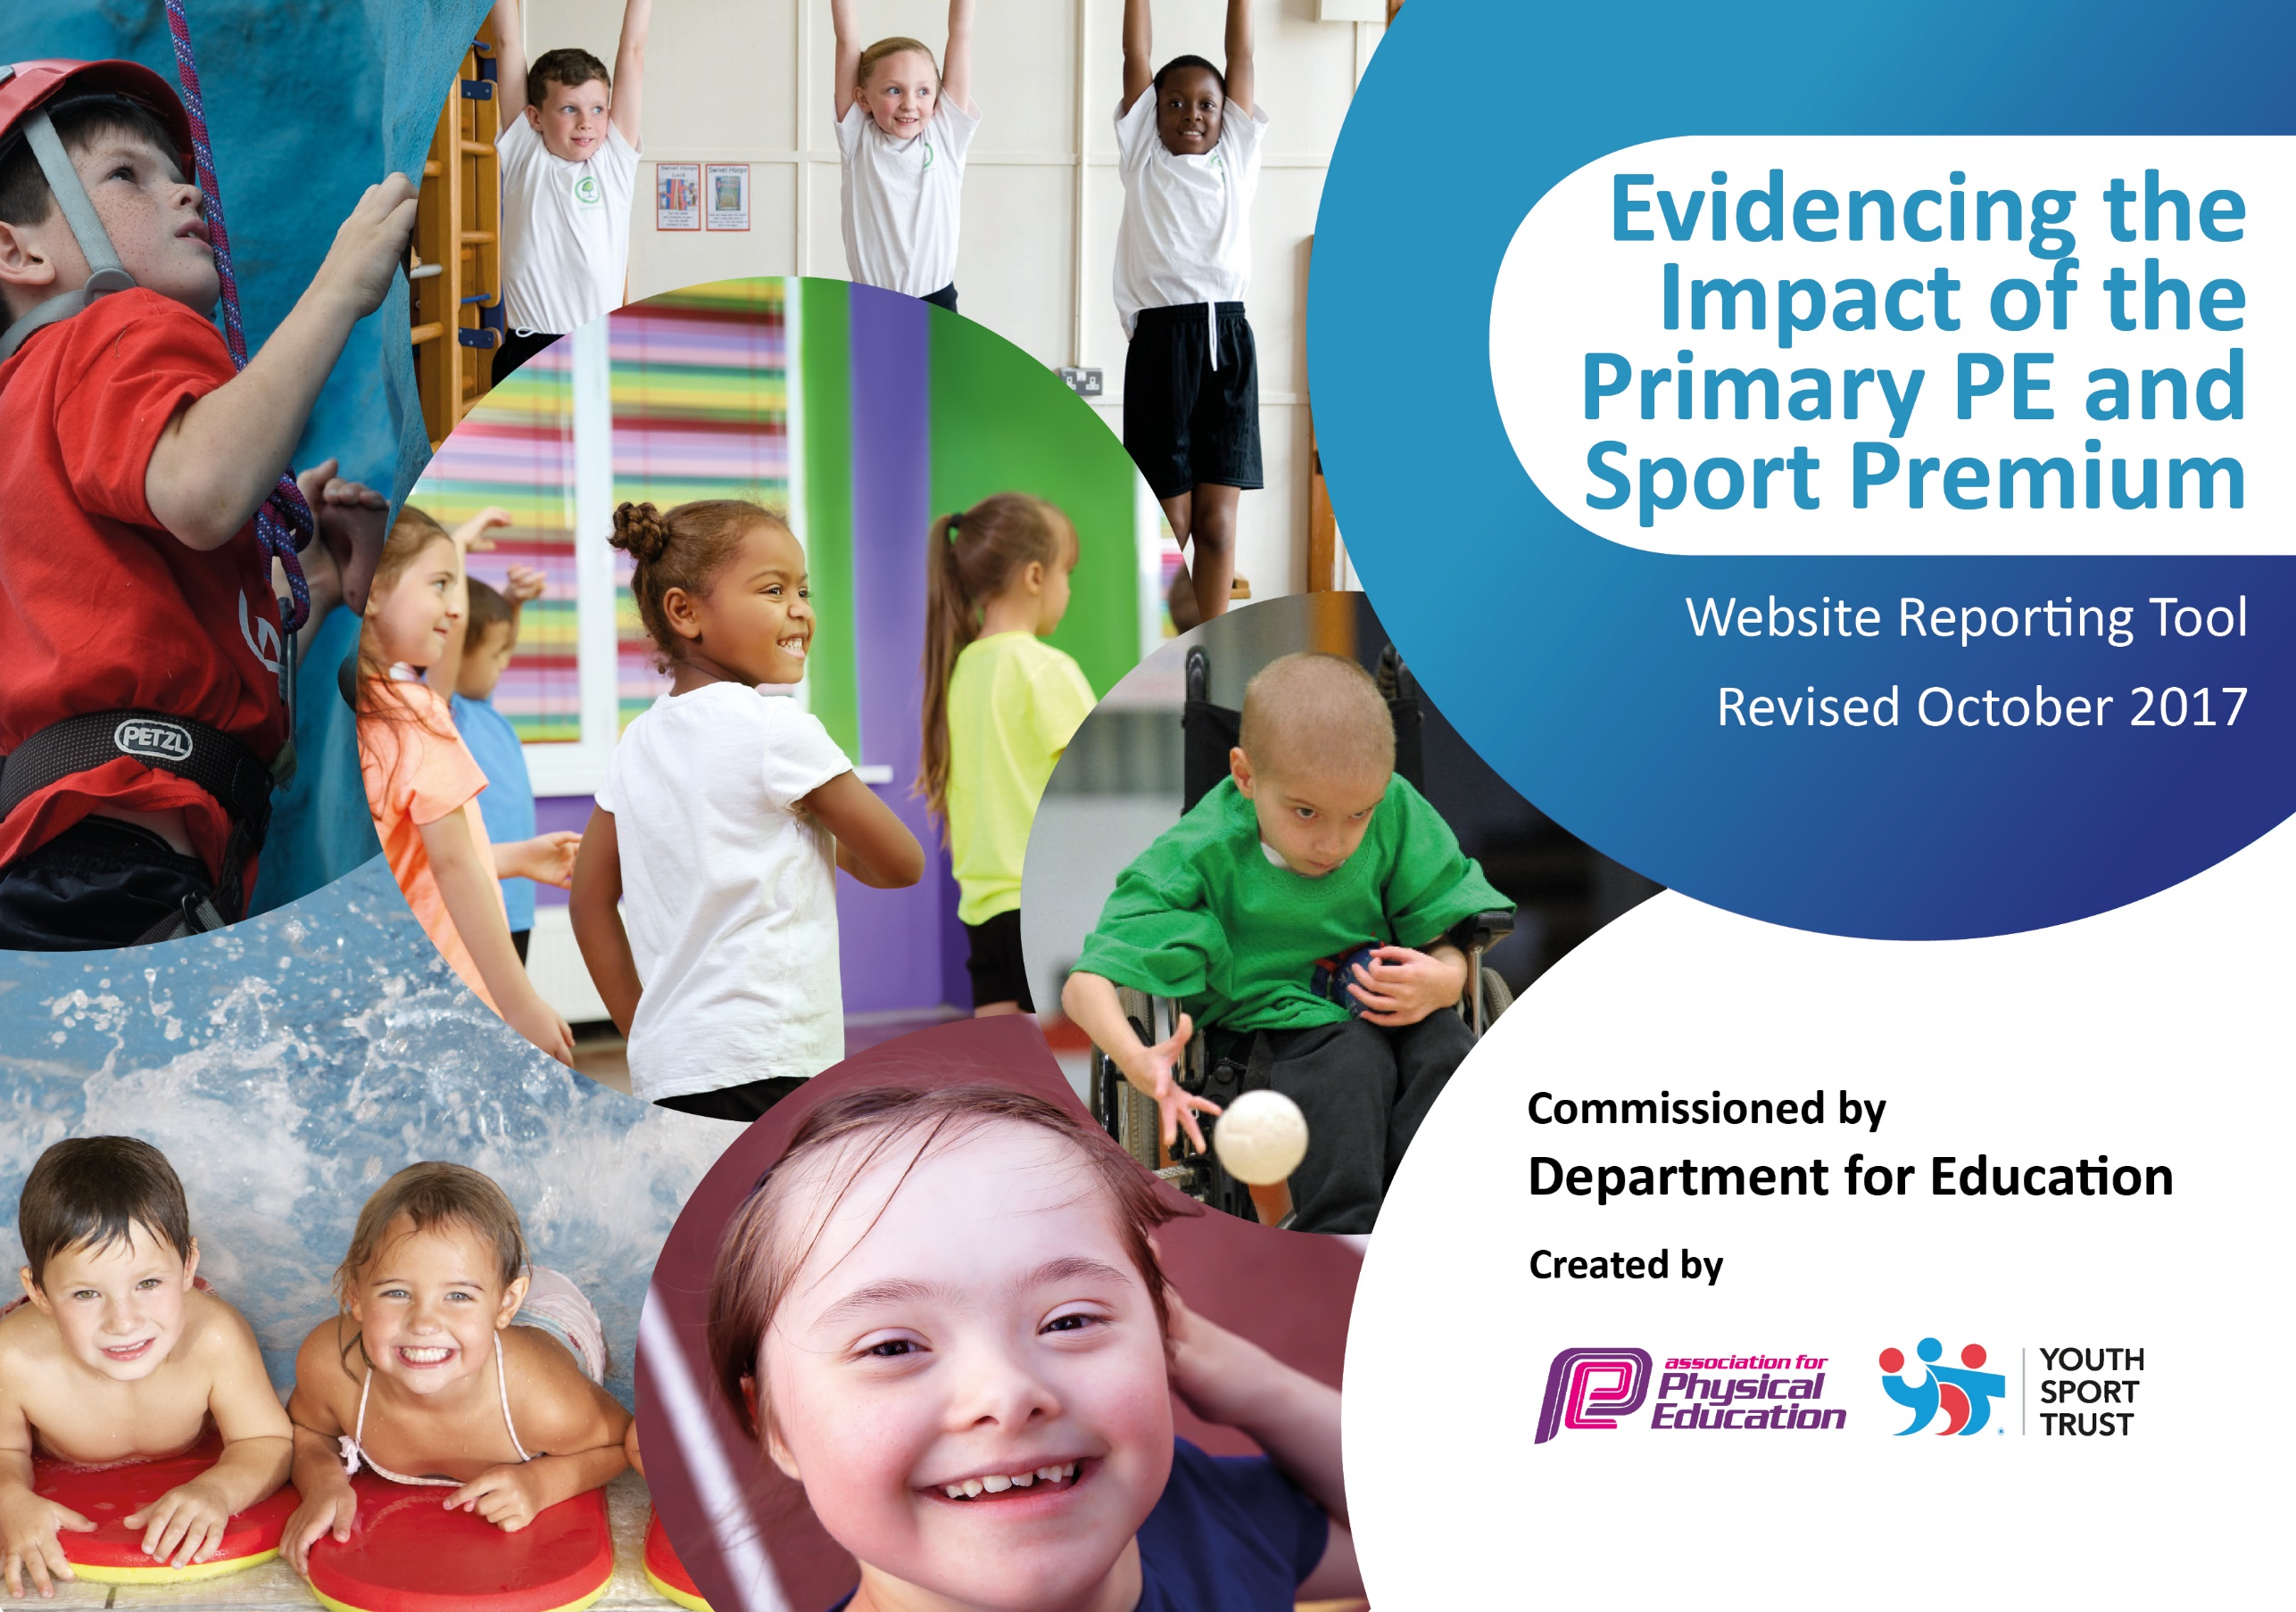

Schools must use the funding to make additional and sustainable improvements to the quality of PE and sport they offer. This means that you should use the Primary PE and Sport Premium to:

- develop or add to the PE and sport activities that your school already offers
- build capacity and capability within the school to ensure that improvements made now will benefit pupils joining the school in future years

Please visit gov.uk for the revised DfE guidance including the 5 key indicators across which schools should demonstrate an improvement. This document will help you to review your provision and to report your spend. DfE encourages schools to use this template as an effective way of meeting the reporting requirements of the Primary PE and Sport Premium.

We recommend you start by reflecting on the impact of current provision and reviewing the previous spend.
Under the Ofsted Schools Inspection Framework, inspectors will assess how effectively leaders use
the Primary PE and Sport Premium and measure its impact on outcomes for pupils, and how effectively governors hold them to account
for this.

Schools are required to publish details of how they spend this funding as well as on the impact it has on pupils’ PE
and sport participation and attainment.
We recommend regularly updating the table and
publishing it on your website as evidence
of your ongoing review into how you are using the money
to secure maximum, sustainable impact. To see an example of how to complete the table please click HERE.

Support for review and reflection - considering the 5 key indicators from DfE, what development needs are a priority for your setting and your students now and why? Use the space below to reflect on previous spend, identify current need and priorities for the future.

Key achievements to date: | Areas for further improvement and baseline evidence of need:
- Employed a PE teacher  - Professionals upskilling staff across a range of sports, including links with the local tennis club  - Get active week – introducing children to new sports and activities  - Implemented the daily mile  - Partake in a comprehensive sports competition calendar  - Football and Netball leagues  - Achieving and maintaining the Gold Schools Game Mark award | - To maintain the Gold Sports Mark Award and work towards achieving Platinum  - Ensure staff CPD continues in order to further develop the delivery of high quality PE  - Swimming booster sessions for children in year 6 2018-2019  - To introduce Physical Education home learning activities

Meeting national curriculum requirements for swimming and water safety | Please complete all of the below:
What percentage of your Year 6 pupils could swim competently, confidently and proficiently over a distance of at least 25 metres when they left your primary school at the end of last academic year? | 88%
What percentage of your Year 6 pupils could use a range of strokes effectively [for example, front crawl, backstroke and breaststroke] when they left your primary school at the end of last academic year? | 83%
What percentage of your Year 6 pupils could perform safe self-rescue in different water-based situations when they left your primary school at the end of last academic year? | 78%
Schools can choose to use the Primary PE and Sport Premium to provide additional provision for swimming but this must be for activity over and above the national curriculum requirements. Have you used it in this way? | Yes/No  No

Action Plan and Budget Tracking
Capture your intended annual spend against the 5 key indicators. Clarify the success criteria and evidence of impact that you intend to measure to evaluate for students today and for the future.

Academic Year: 2017/18 | Total fund allocated: £ 19,580.00 | Date Updated: 28.3.2018
Key indicator 1: The engagement of all pupils in regular physical activity – Chief Medical Officer guidelines recommend that primary school children undertake at least 30 minutes of physical activity a day in school |  |  |  | Percentage of total allocation:
 |  |  |  | 7%
School focus with clarity on intended impact on pupils: | Actions to achieve: | Funding allocated: | Evidence and impact: | Sustainability and suggested next steps:
- Daily mile – Increasing physical activity levels.  - Playground – Offering opportunities for 30-60 minutes physical activity per day.  - 30 minutes of activity school’s responsibility.  - 30 minutes outside of school | Held before school three times a week. It is then ran twice a week in school.  Registers of children attending and how regularly they attend (targeted groups) Inside classroom.  Move Daily Mile into school time so more children take part.  Zoning the school playground at lunch time and playtimes to structure play and increase physical activity. MSA need to be responsible for ensuring children are active for 30 minutes at lunch time.  Classes to do Go Noodle each da  Survey children in PE lesson with ZF to see what physical activity they do outside of school. | £0  £1399.79  £0  £0 | Daily mile is now happening every day within school time. All pupils’ physical activity levels have increased. Pupils are aware of why they take part in the daily mile. Pupil voice shows that most pupils enjoy taking part in the daily mile (72%) (See P voice and photos).  Training has been run for year 4 and 5 children to become safe and effective leaders. All pupils are engaged in a wide range of activities at lunchtime.  MSAs have received training and are confident in supporting the play leader scheme. Pupil voice shows that 83% of pupils enjoy participating in playleaders. However, they would like more equipment, especially balls.  Staff meeting has been run to introduce Go-Noodle. Classes are actively using this between lessons at least once a day, increasing the level of physical activity for every pupil. .(Photos)  Still to be completed | To measure the impact of physical exercise before a child is assessed.  To consider other forms of exercise.  Play leaders to be trained and regularly monitored by a member of staff.  New resources and equipment to be purchased.
Key indicator 2: The profile of PE and sport being raised across the school as a tool for whole school improvement |  |  |  | Percentage of total allocation:
 |  |  |  | 0.3%
School focus with clarity on intended impact on pupils: | Actions to achieve: | Funding allocated: | Evidence and impact: | Sustainability and suggested next steps:
- PE Board –  - Assemblies  - Newsletter  - Get active week – July 2018  - YST Quality Mark | Sports captains to update PE board. Keeping children up to date with sporting opportunities, clubs, results, upcoming fixtures, house points, school captains and sports captains.  After each match, fix or competition that is intra-school the captain of that particular competition should prepare a report to read out in assembly. Every sporting event is communicated to parents in the weekly newsletter.  Communicating sporting clubs, fixtures, results and achievements with parents.  Introduce children to a wide range of sporting activities.  Buy into the YST in order to track the provision in school and find out where the gaps are to improve provision. | £0  £0  £0  £75  TBC – Dependent on activities brought into school. | Photo, children know upcoming events, previous results of competitions, school house points are visible on the board which links to interhouse/class sports competitions  Children write and share their sports reports in assembly. Children are aware of opportunities for sport in school. These are shared in our weekly school newsletter.  See school website for newsletter write ups.  All children from nursery to Year 6 got to experience a variety of activities including bounce, Zumba, tag rugby, football, hockey and a biathlon all run by outside coaches. Plus, orienteering and inter house kwik cricket tournaments organised by staff. Children were fully engaged. Pupil voice shows that pupils enjoyed their bounce sessions as they found it fun (Photos)  Still to be completed | To be regularly updated  To introduce a separate sorts newsletter once a term, celebrating the school’s achievements. Sports captains to help complete this.  To run a get active week every other year. Many

Key indicator 3: Increased confidence, knowledge and skills of all staff in teaching PE and sport |  |  |  | Percentage of total allocation:
 |  |  |  | 18%
School focus with clarity on intended  impact on pupils: | Actions to achieve: | Funding  allocated: | Evidence and impact: | Sustainability and suggested  next steps:
- Planning PE with specialist teacher.  - Upskilling teachers in lesson  - Specialist teacher with PE coordinators to run staff meetings with focus on teaching high quality PE lessons.  - Primary Sport and PE Conference | PE teacher to plan HQPE with all staff, discuss planning and content.  Team teaching PE lessons. Now focusing on NQT’s and year 1 teachers who haven’t yet benefited from long term upskilling.  Set a date to lead a staff training session on PE. Survey all staff on their needs and develop a tailor made session.  Book ZF and RG onto the course. | £3306.97  As above  £0  £150.00 | All medium term plans written for the spring term.  It has empowered teaching staff to have the confidence to teach a wider range of sports and teach higher quality lessons consistently. Teacher survey indicates that staff would like additional training in gymnastics and dance. End of year data shows that 97% of pupils are working at age related expectations and 21% are working above  Staff survey showed that teacher’s require more CPD in gymnastics and dance.  Teachers attended the Primary PE conference.  Seminars booked were:  - Evidencing the impact of Sports Premium.  - Raising the profile of PE in school  - EYFS gymnastics – ideas fed back to EYFS team to use in PE.  - Identifying what outstanding PE is and seeing how this compares to current school PE standards. | Further time to be allocated for other units of work to be discussed and planned with PE specialist.  Teaching staff can share new knowledge with other members of staff.  Upskilling to continue next year using sports premium budget. Staff meeting on gymnastics.  To raise the percentage of children working at greater depth.  Training still to be delivered.
Key indicator 4: Broader experience of a range of sports and activities offered to all pupils |  |  |  | Percentage of total allocation:
 |  |  |  | 9%
School focus with clarity on intended  impact on pupils: | Actions to achieve: | Funding  allocated: | Evidence and impact: | Sustainability and suggested  next steps:
Additional achievements:  Outdoor Learning  Get Active Week  To purchase new equipment to support lessons.  Swimming  American Football  Tennis | Send staff on training for outdoor learning Spring Term l. The aim being to increase the amount of outdoor learning and physical activity children gain in a day.  As above  Audit resources, purchase new equipment.  Children who are unable to swim 25m by year 6 will be offered top up sessions.  Specialist PE teacher trained to deliver American Football in school.  Equipment purchased to support teaching in lessons and school clubs.  Year 5 and 6 pupils to have 6 weeks tennis coaching at the local tennis club. | £ 270.00  £ 92.84 (items for developing outside area)  As above  £427.80  £Costs to be confirmed.  £350.00  £630 | Teacher have been provided with a range of ideas and activities to support cross curricular outdoor learning. Teachers are incorporating more outdoor activities in weekly lessons. (See planning). The wooded area has been cleared by a working party from Nationwide building society to provide an area for outdoor learning.  New football and netball goal nets purchased for friendly and competitive league matches. New bibs ordered for lessons. Children are able to participate in inter house and competitive sports with safe and appropriate equipment.  Summer term  All pupils received 6 weeks of tennis coaching. Teaching staff are upskilled in tennis and able to incorporate this in own lessons. | To continue monitoring planning. Provide further training on outdoor learning. To conduct pupil voice  Year 6 pupils to have an intensive course if not meeting requirements.  Year 5 and 6 teachers to feedback and share skills and ideas with staff to support future planning and lessons.
Key indicator 5: Increased participation in competitive sport |  |  |  | Percentage of total allocation:
 |  |  |  | 24%
School focus with clarity on intended  impact on pupils: | Actions to achieve: | Funding  allocated: | Evidence and impact: | Sustainability and suggested  next steps:
- Interclass/inter house competitions  - Inter house – Sports Day  - KAS Football and cricket league  - BSP Competitions – Some children across KS1 and KS2 will be invited to participate in a wide variety of sports against other schools.  - Partnership Netball/Cricket/ Rounders Leagues  - Platinum Package – CPD for staff, G&T, SEN and disengaged opportunities for children. Leagues, KS1/2 multisports festival, KS1 dance festival, cluster competitions, rounders league, swimming gala, use of BSP equipment, active learning resource pack. | All children to be given the opportunity to play against their opposite class peers in competitive situations.  Children participate in various games/matches in classroom PE.  Children compete in a whole school inclusive house event. PE teacher to structure the day. Staff to be allocated jobs to support the day.  Football and cricket sessions for boys and girls (funded from the Sports Premium) allowing children the opportunity to train and compete in school matches/tournaments.  Lunchtime club  Timetable to be provided in staffroom. Staff need to be allocated to help support and attend each event.  Team entered for Spring netball leagues, cricket and rounders leagues to be entered when the invites come out in the summer term.  Ensure staff attend CPD sessions that are run by the partnership. Enter all competitions and festivals. | £54.90  (stickers)  £1875  £1883.33  (one term, plus a whole year)  £179.50  (Cover and adults to attend events/first aid)  Included in cost above  £670 | Photos of classes and houses competing against one another. All children are having opportunity to participate in competitive sport in a safe and fun environment.  Sports day is the schools biggest inter-house competition in the school calendar. 100% of children participate in this demonstrating a variety of track and field events making this event fun and inclusive – See photos for format and whole school inclusivity.  Year 5/6 children participating in a football and cricket club with specialist coaches.  Year 5 and 6 pupils active and engaged at lunchtime.  Children experienced a variety of different activities and competitions. Staff upskilled at events. | To continue to build on this so that all year groups take part. To ensure this happens once a term.  The events to be allocated to key stages to be organised by teachers.

