Dear Parents 23rd September 2016

Inset Day
There will be an inset day on Thursday, 5th January 2017. Please put this in your diary.

Voluntary Helpers
There will be a safeguarding presentation for voluntary helpers at 9.10am on Tuesday 27th September in the library. I look forward to seeing as many volunteers as possible. Please note there will be no guided reading.

School Journey 2016
Thank you to those parents who have kindly returned their consent forms, however we still have some forms outstanding and would appreciate it if you could arrange for these to be sent in as soon as possible. We note that NHS numbers are missing from some of the returned forms, please contact your child’s GP for this information and send it soonest. Thank you.

Years 5 & 6 Maths Evening
There will be a maths evening for parents in years 5 and 6 only on 9th November between 6.45pm and 8.00pm. The evening will explain how we teach maths calculations in the upper juniors. We hope you can make it.

Year 5 - UK Space Agency
Heather MacRae from the UK Space agency came into school to talk to year 5 about being an astronaut and brought in an actual spacesuit which the children thoroughly enjoyed.

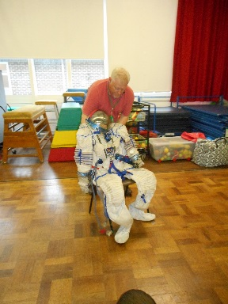

School Dinners
The children have settled down into a happy routine and are enjoying their school dinners. Please note that children can have dinners either:
Every Day Wed Roast or Fri Favourites Wed Roast + Fri Favourites
Some children are still changing their options during the week which can lead to problems with the kitchen orders. Please can you ensure your child is aware of what their weekly choices are. Thank you.

Tennis Club
Although I put a request in my newsletter of 9th September asking parents to park considerately in the tennis club car park, I have just been informed by Mr Gay of the tennis club that the top car park will now be locked from 2.00pm-3.30pm every weekday, due to continued thoughtless parking by some Northgate parents. Unfortunately we have now lost this valuable facility.

As a consequence, there will be more traffic in Cricketfield Lane and I urge parents to park responsibly.

Northgate Association AGM
The parents association AGM will be held at 7.30pm next Wednesday, 28th September in the school hall. Mr Cavendish (class 8 teacher) has kindly offered to join the association and will be looking forward to meeting lots of prospective members.

Thank you very much to Mrs Rana and Mrs Vandenberg for their kind donations of books.

Community News

Hockerill Anglo-European College
The school are holding an open evening for prospective year 7 residential boarders for 2017 entry only, from 6.30pm-8.00pm on 7th October. You can register by emailing prospective applicant details (name, gender and date of birth) at admissions@hockerill.com by 4th October.

St Mary’s School, Cambridge
The school is holding an open morning for 2016-2017 admissions at 9.30am on Saturday, 8th October. If you require any further information please contact Emma Hall, Assistant Head: Acting Head of Admissions at ehall@stmaryscambridge.co.uk or on 01223 224166.

Yours sincerely

L Hotson
Headteacher

